**COP529 Data Mining Assignment by Keunwoo Kim(F429147)**

**Part 1.**

To transform the census data into a more meaningful form, I have created Cleaned_census_data.csv, as presented in Figure 0. The Cleaned_census_data.csv includes the transform of nine columns and added Industry column, which explains the industry type of the occupation column numeric codes.

Before performing exploratory data analysis to understand the dataset’s structure and key

characteristics, I would like to explain the data transformation process briefly.

The CoW numeric code has been categorised using the Edit Domain widget (Figure 1).

**Figure 1.**

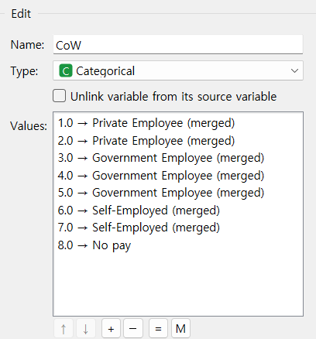

The Edit Domain widget categorises the education numeric code (Figure 2).

**Figure 2.**



The marital numeric codes followed the same process (Figure 3).

**Figure 3.**

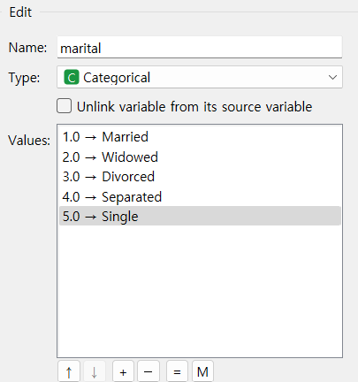

Due to its massive variable, the occupation data was first merged as Left Join with the Attribute_Values data file.

**Figure 4. Selected the Occupation column**

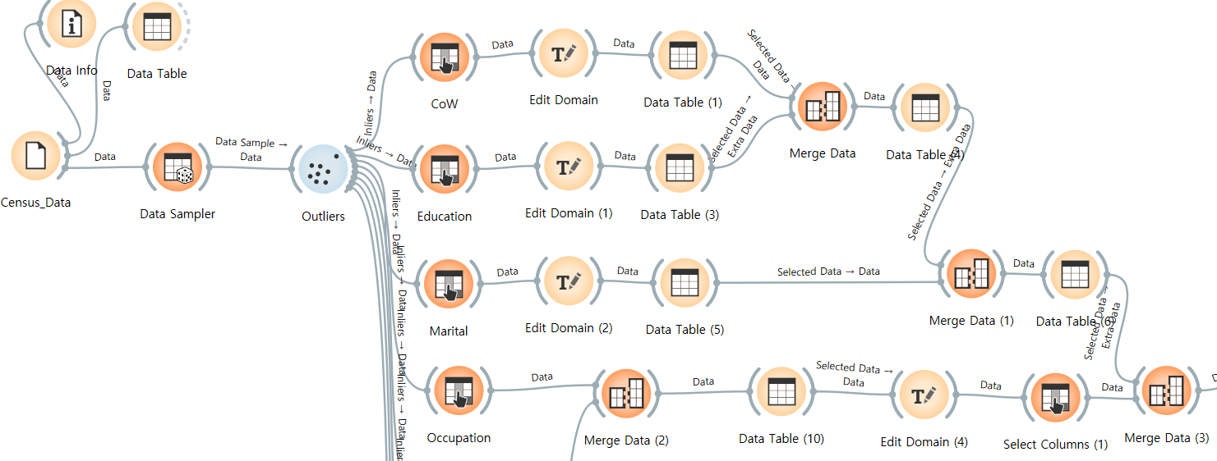

**Figure 5. Selected Occupation row**

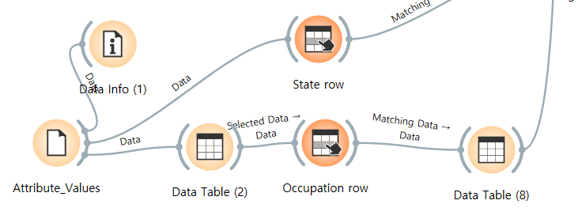

The Occupation column and row from each data file have been merged (Figures 4 and 5).

Afterwards, using the Edit Domain widget, the Value column was reinterpreted as categorical data, and its value was based on the first three characters (Figure 6) and displayed as a pair of numeric codes referred to earlier.

**Figure 6.**

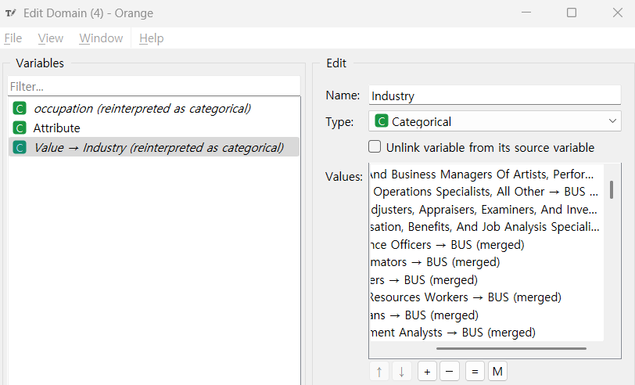

The PoB column followed a transformation process similar to the Marital column, categorising it into US and non-US (Figure 7).

**Figure 7.**

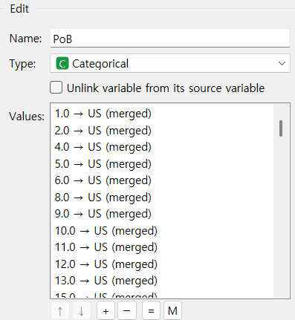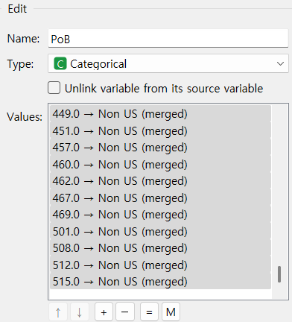

The sex column has been categorised into Male and Female (Figure 8).

**Figure 8.**

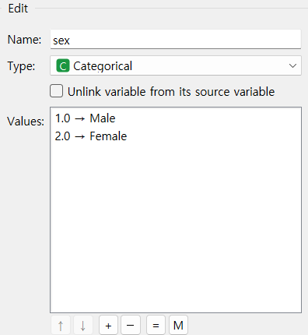

The Race column has been categorised into White and non-White (Figure 9).

**Figure 9.**

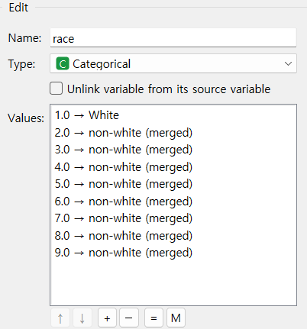

Due to its massive variable, like the Occupation column (Figure 5), the State column was merged as a left join with the Attribute_Values data file. Its numeric code was replaced with an actual state name (Figure 10).

**Figure 10.**

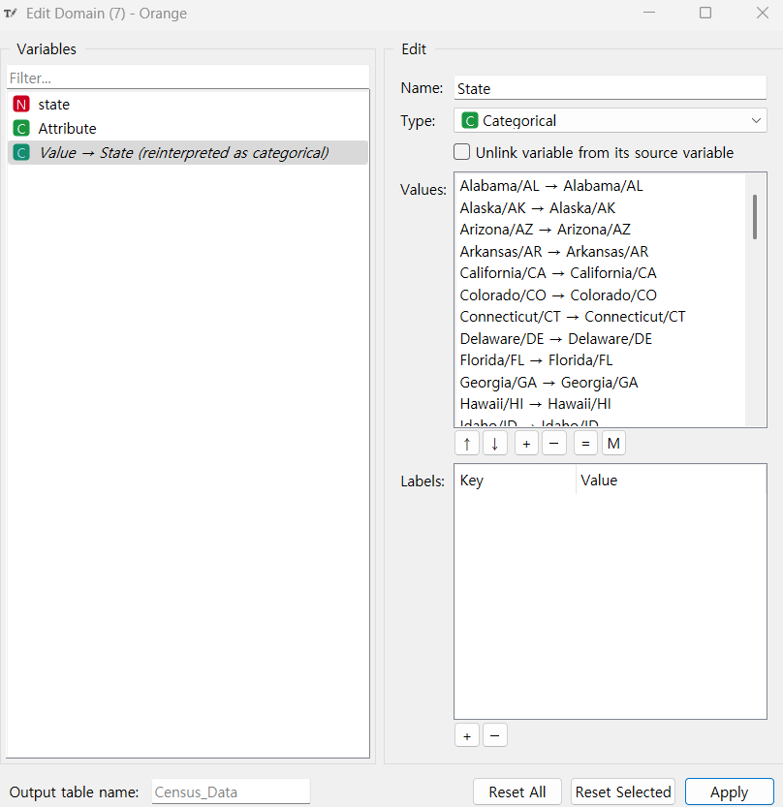

As is visible in Figures 11 and 12, each transformed Column has been merged and composed of the Cleaned_census_data.csv (Figure 13).

**Figure 11.** **The whole process of data transformation**

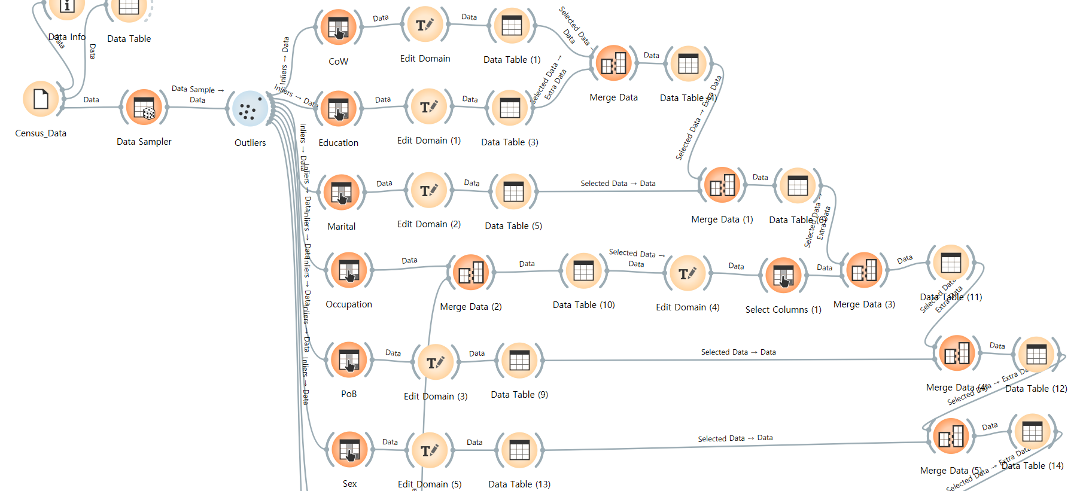

**Figure 12.** **The whole process of data transformation (Continued image of Figure 11)**

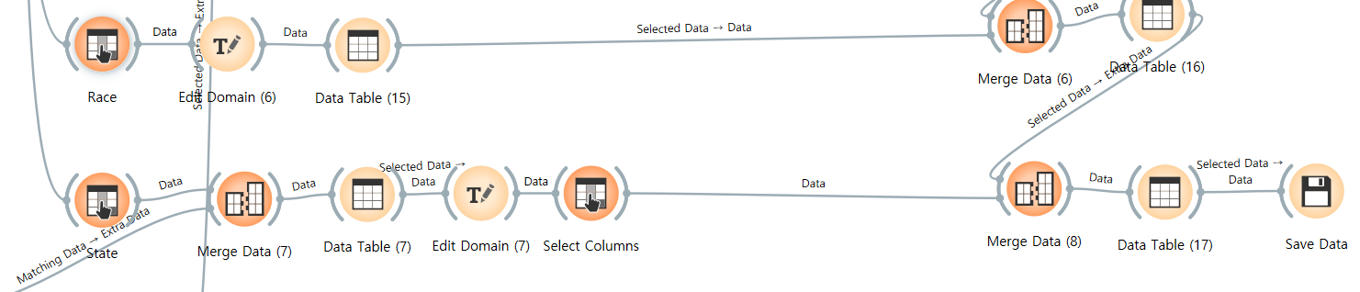

**Figure 13. Cleaned_census_data.csv**

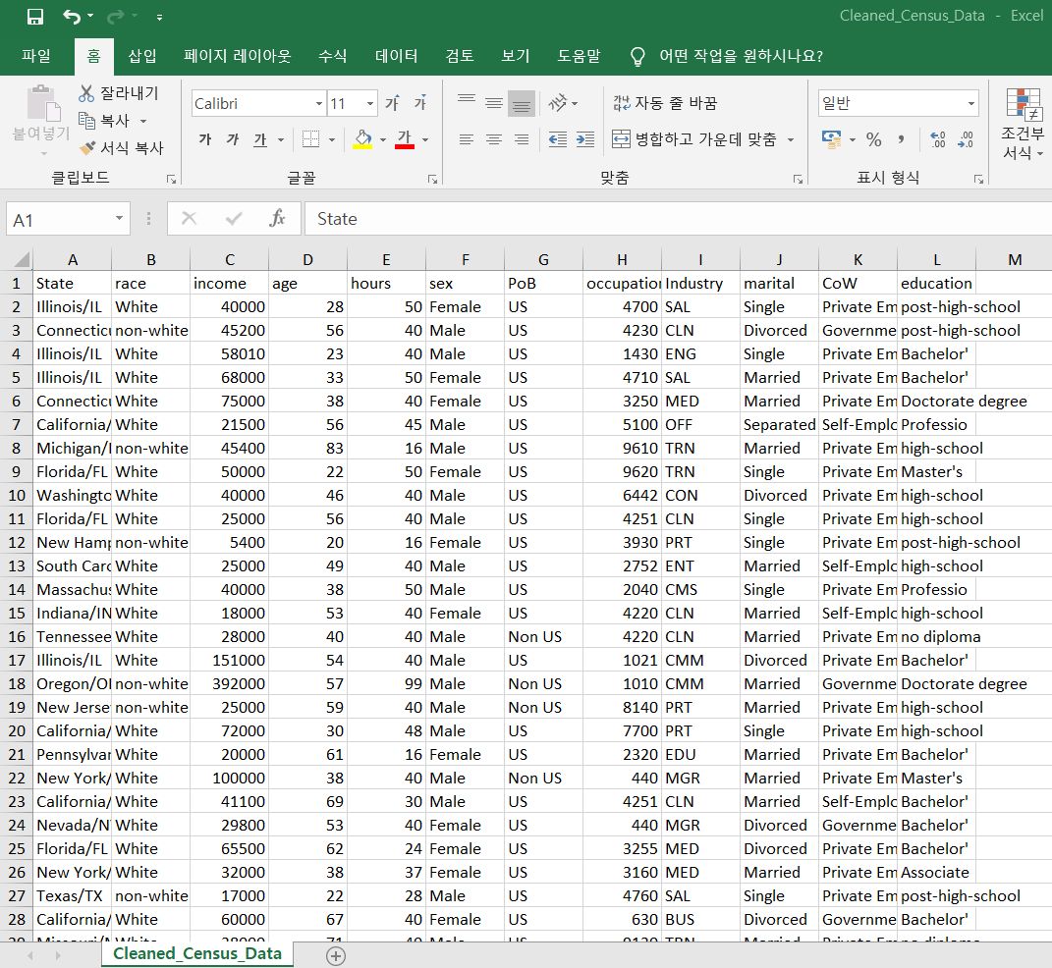

At the beginning of the workflow, the outlier widget uses the Local Outlier Factor. However, according to the box plot result of the Income column, the Standard deviation is exceptionally high by around 67,645 (Figure 14). Therefore, I excluded incomes over 500,000.

To briefly mention the exploratory data analysis, according to the cleaned census data, white ethnicity was superior by 78.23% regarding race.

Sex data is more balanced by 51.79% (Male) and 48.21%(Female).

The review of the correlation between income and continuous variables, such as age and hours, showed 0.24 and 0.33, which is a bit weak and at a medium level of correlation (Figures 14 and 15).

**Figure 14.**

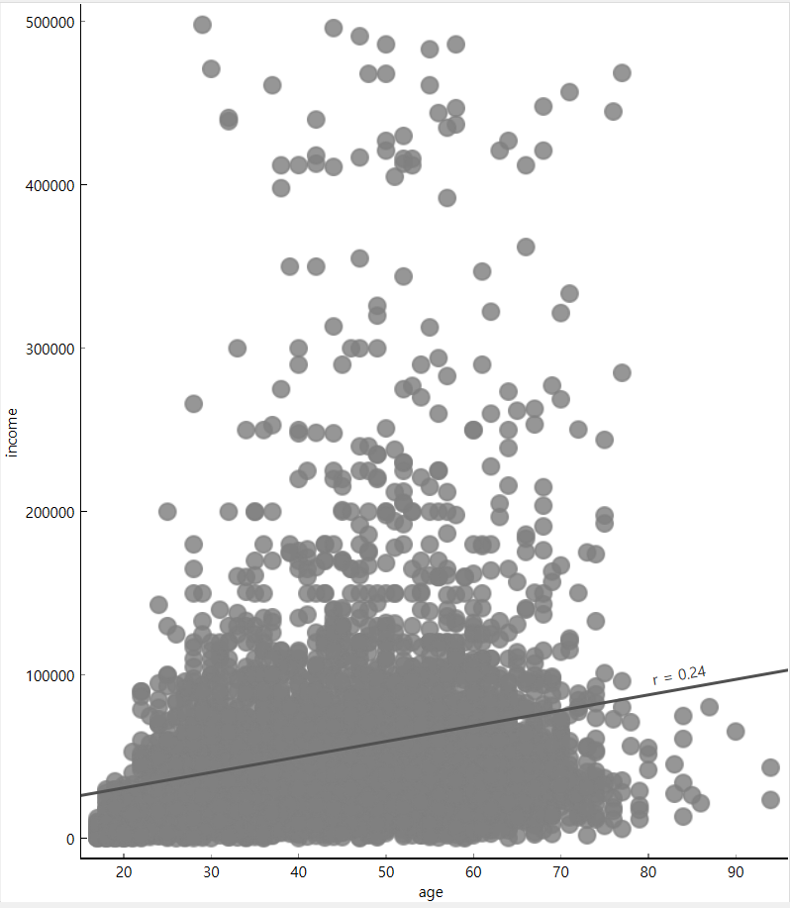

**Figure 15.**

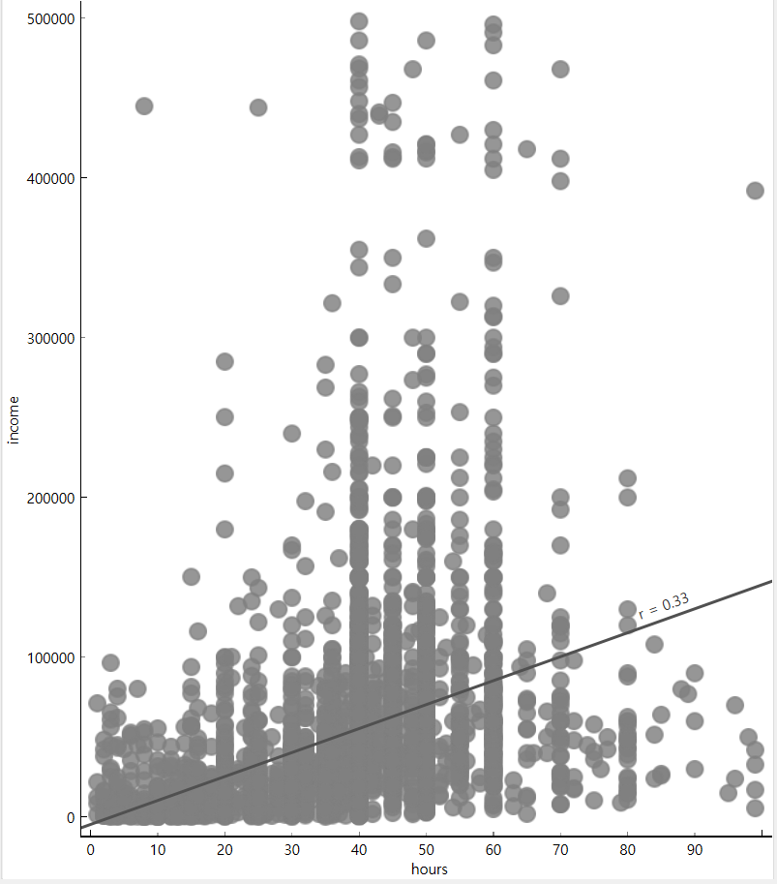

**Part 2.**

By applying the log transformation, the income histogram became more of a normalised distribution from the right-skewed graph (Figures 16 and 17).

**Figure 16.**

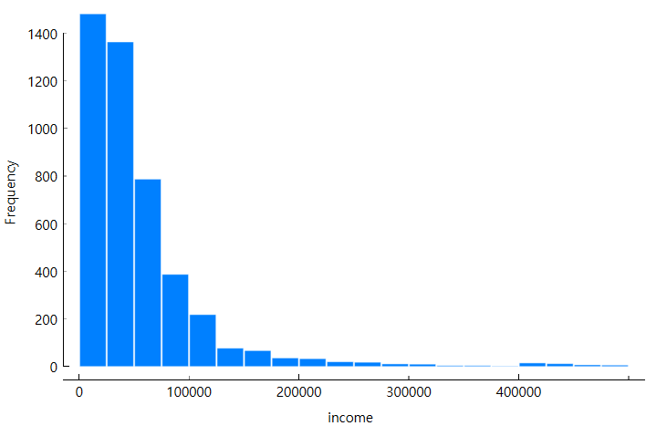

**Figure 17.**

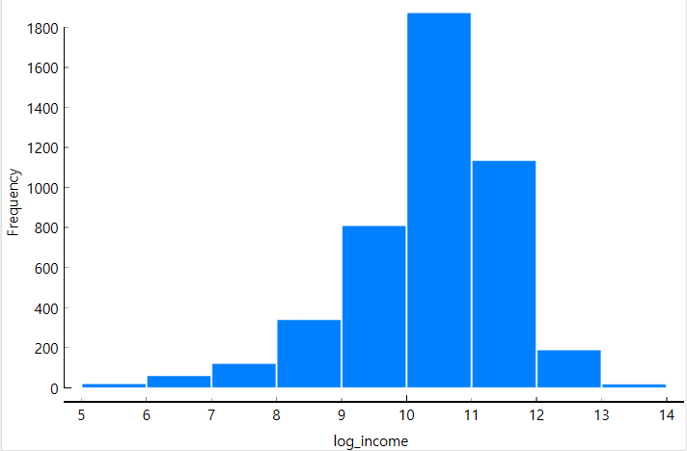

Creating a rank list using Excel could create a Zipf plot. However, the scatter plot does not follow Zipf’s law as the R-value is not close to -1 by -0.01 (Figure 18).

**Figure 18.**

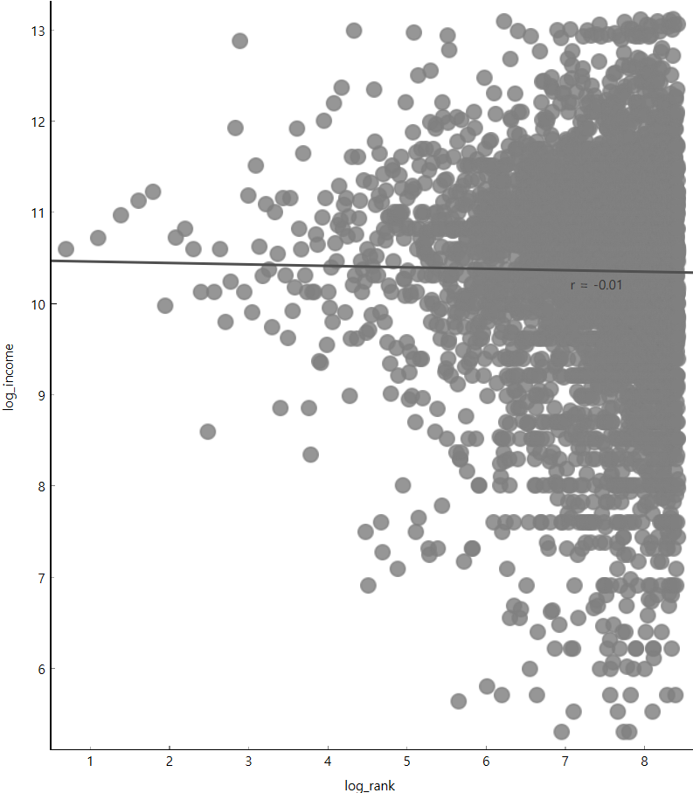

Analysis by Box plots are adequate as they provide various results, including min/max, average, T-value, etc.

According to Figure 19, there is a difference in income by gender. The male’s average log income is higher by around 10.53, while the female's is around 10.17. Furthermore, the T-value is significantly high by 10.708, which means that the average difference between the two genders is relatively high. Likewise, the P-value was very low at 0.000, meaning there is a 0% possibility of getting a value higher than the current T-value.

**Figure 19.**

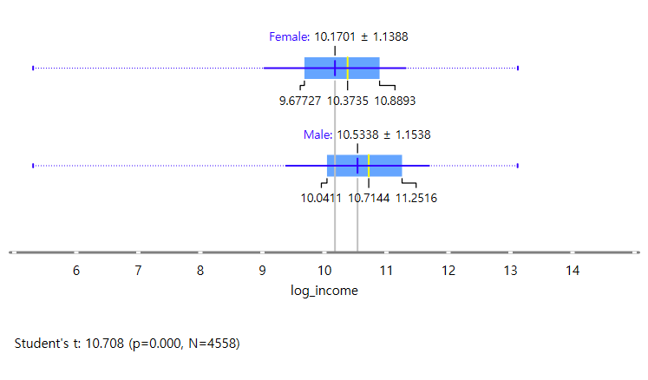

In terms of race, there was an income difference between Whites and non-whites. The White group's average log income was relatively higher by around 10.40, while the non-white group averaged around 10.21, according to Figure 20. Like the previous result, the P-value of the race attribute is 0.000. However, the T-value is less extreme than the sex attribute by 4.535 (Figure 20).

**Figure 20.**

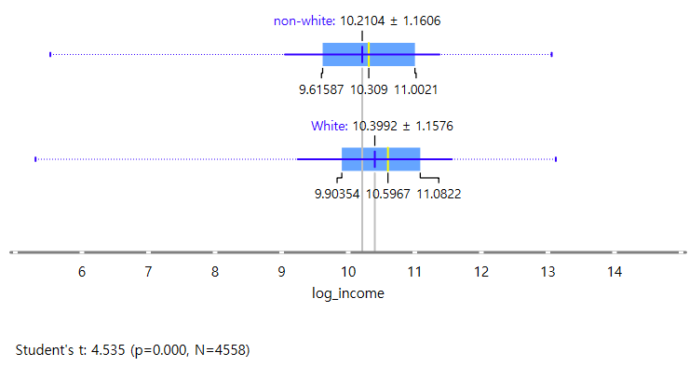

On the other hand, the PoB showed no significant difference between the US and non-US groups. The T-value was low by 0.130, which led to an increase in the P-value by 0.896, meaning there is almost a 90% probability of occurrence value over the T-value (Figure 21).

**Figure 21.**

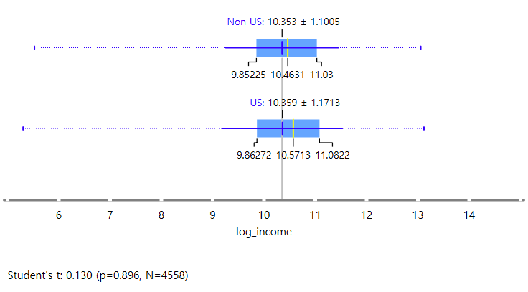

The following workflow in Figure 22 has been processed to investigate the correlation.

**Figure 22.**

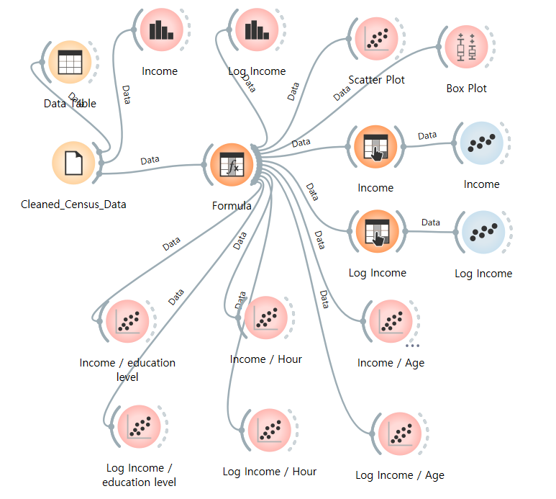

As previously mentioned in Part 1, the correlations between hours and age showed a slightly weak correlation at each R-value of 0.329 and 0.241 (Figure 23). Furthermore, the correlation between educational level and education is somewhat weak by 0.285 (Figure 23).

**Figure 23.**

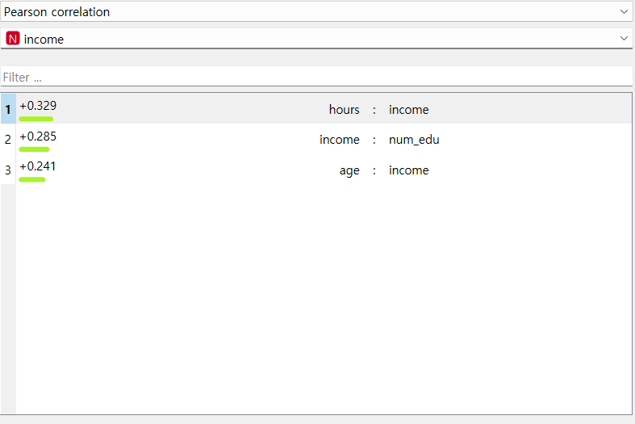

However, applying log transformation increased the R-value (Figure 24).

The previous R-value was expected to be distorted due to the extraordinarily high-income earning population. The log transformation decreased the impact of outliers and formed a better linear relationship.

As a reward for that, age and educational level show distinct correlations, and hours show strong correlations (Figure 24).

**Figure 24.**

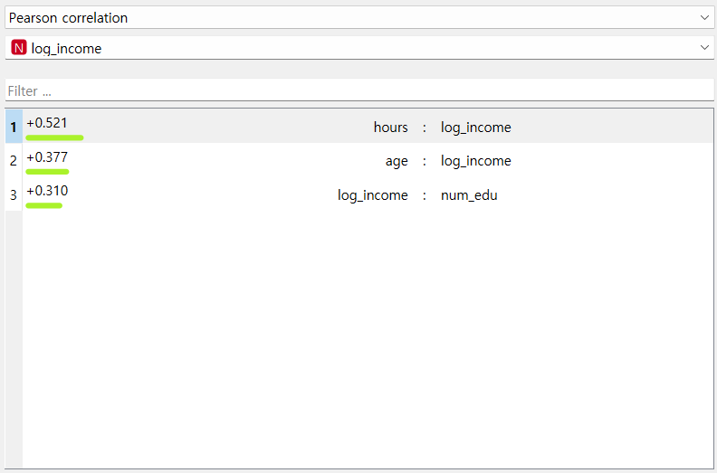

**Part 3.**

This part of the report will focus on Income prediction. Plotting income against education level showed that the mean increased as the education level increased (Figure 25).

**Figure 25.**

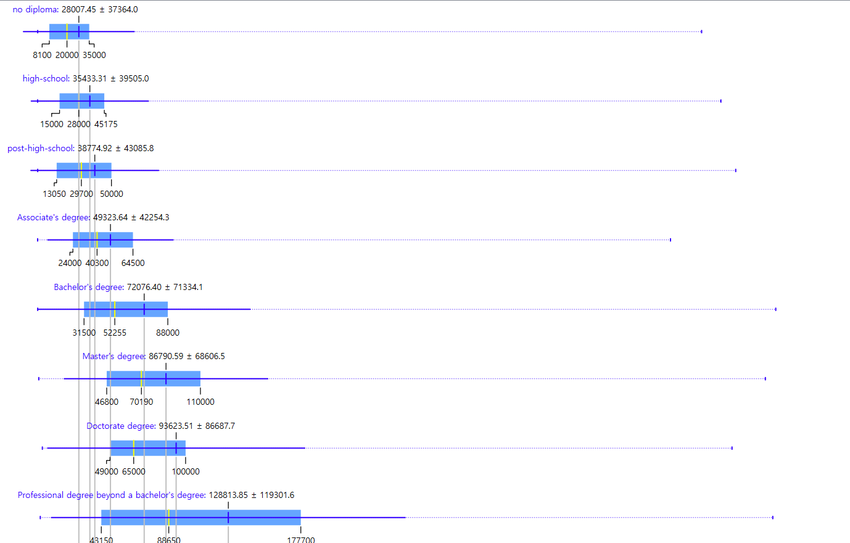

By applying linear regression (Figure 26), the monetary value of education was estimated to be around $273 per increase in numeric education level (Figure 27). However, this result does not contain the effect of the level of education, as it is concentrated on the rise of education yearly. Therefore, it is hard to explain how education level impacts income fully. Furthermore, the linear model’s performance is extremely low, as shown in Figure 28. Considering MSE and RMSE, it interprets that the model’s prediction is far different from the actual value, which led to a low R² value, meaning it is more of a predicting random value. To increase model performance, I have tried to apply log transformation, change attributes, and fit hyper-parameters, but it still wasn’t possible to get meaningful results using the income attribute as a continuous value.

**Figure 26.**

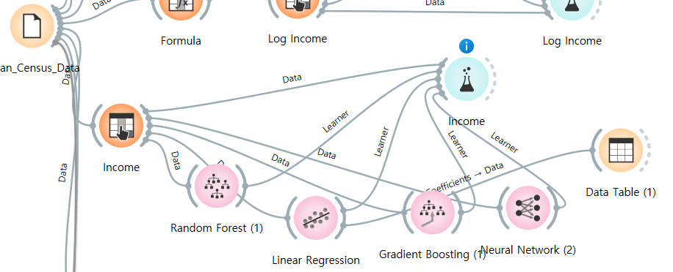

**Figure 27. Income Increase by Increase of Education Level**

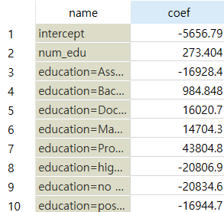

**Figure 28. Test & Score Result**

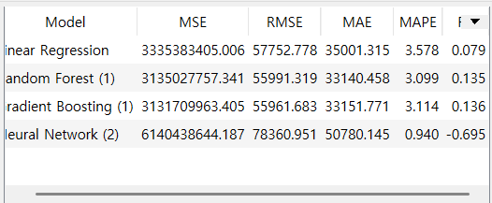

The model's performance was reinforced by binary classifying Income into “Low Income” and “High Income” groups based on the median.

Test several classification models, as displayed in Figure 29. The gradient-boosting model scored the highest among the six models, scoring 0.876 in AUC. The AUC represents the classification model's overall performance higher as it gets closer to 1 (Figure 30).

**Figure 29.**

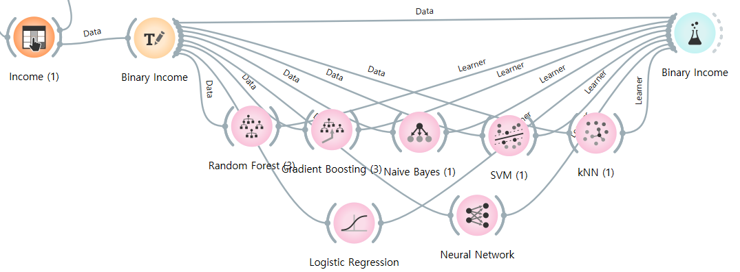

**Figure 30.**

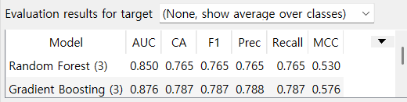

The rank widget in Figure 31 shows that hours, occupation, age, and num_edu (education level in numeric code) are crucial attributes, as they scored in the top four in importance for the Gradient Boosting model (Figure 31).

**Figure 31.**

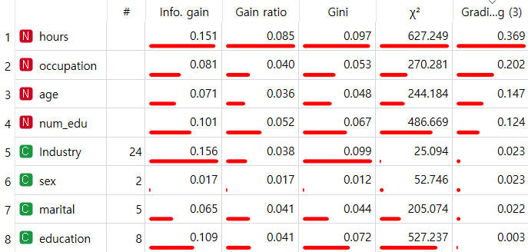

Regarding the importance of the analysis by SHAP and Feature importance, it was spotted that both results prioritise age over occupation, unlike the feature ranking (Figures 32, 33, and 34).

In conclusion, the three analyses agreed that hours, age, and occupation are the key attributes. However, age and occupation were prioritised differently.

**Figure 32. High Income by SHAP**

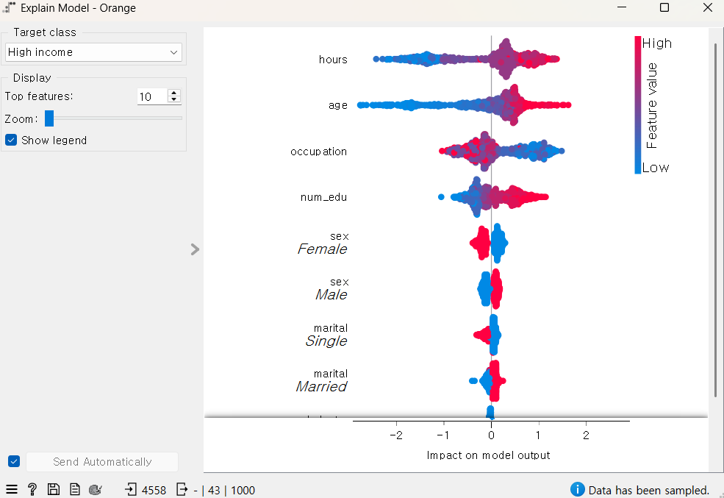

**Figure 33. Low Income by SHAP**

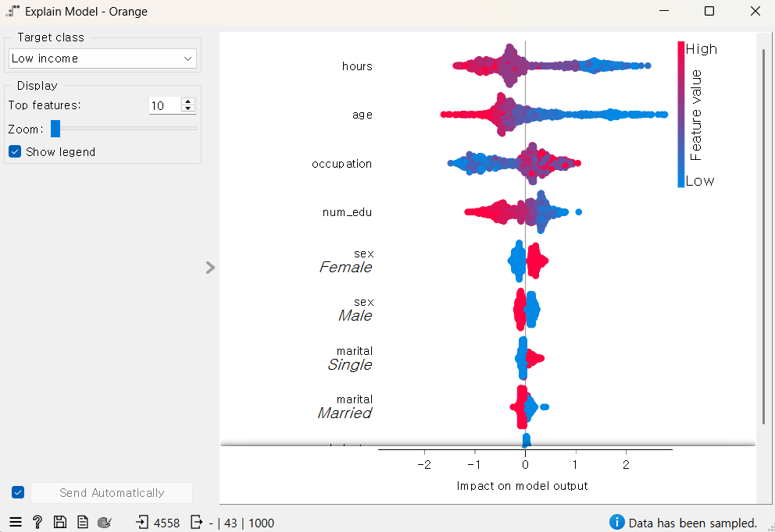

**Figure 34.**

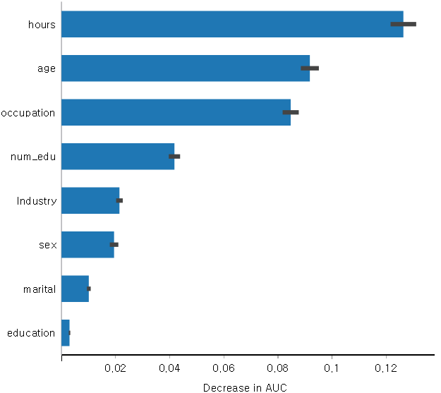

**Part 4.**

This part of the report analyses and discusses the 2020 US presidential Election.

The mean income, educational levels, and election results by state will be displayed on the US map. The result will examine the hypothesis that “low-income states voted for Trump” and that “states with high educational attainment voted for Biden.” To simplify the visualisation interpretation, the mean income and education level were binary and classified using the median as a standard. Categorising the attribute and using the median as a standard minimises the effect of outliers and improves understandability when visualised.

Biden was elected president during the 2020 election. According to Figure 35, Biden outperformed Trump in 30 out of 51 states.

Regarding Figure 36, the States with low average income are red. 26 States were classified as low-income, and Trump was dominant in 10 States among low-income states (Figure 37).

Figure 38 shows that 25 states were classified as having a high education level, and Biden was dominant in 15 States (Figure 39).

In conclusion, according to the simple comparison by visualisation, the first hypothesis should be rejected as the low-income states voted for Trump less than 50%. However, the second hypothesis is relevant as states with high educational attainment voted for Biden over 50%.

**Figure 35.**

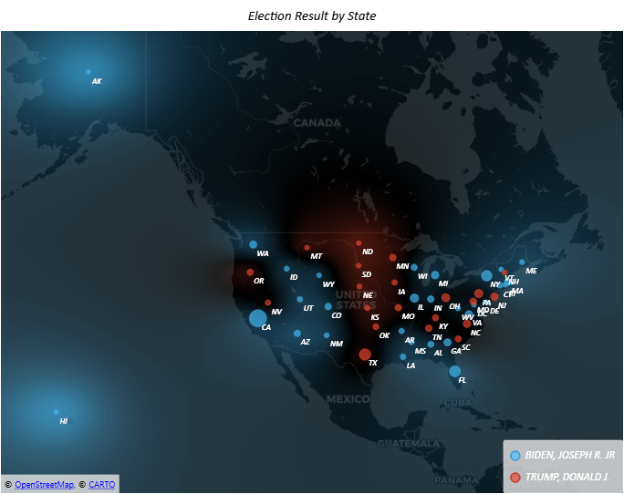

**Figure 36.**

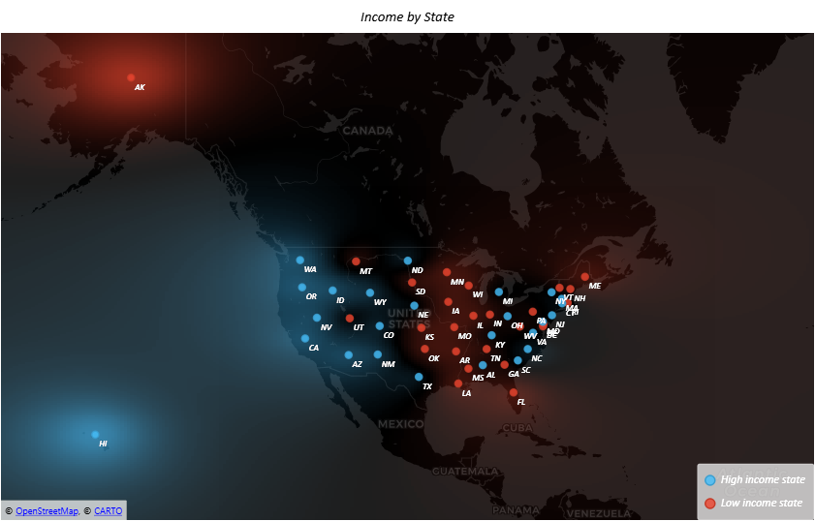

**Figure 37. Trump Won in Low-income States**

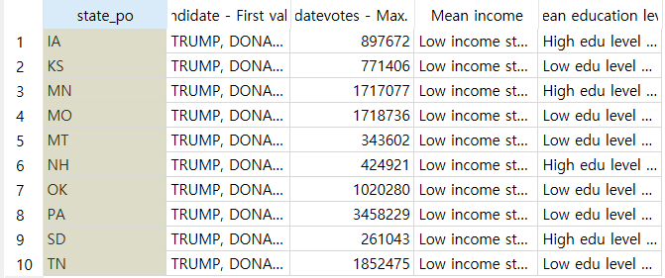

**Figure 38.**

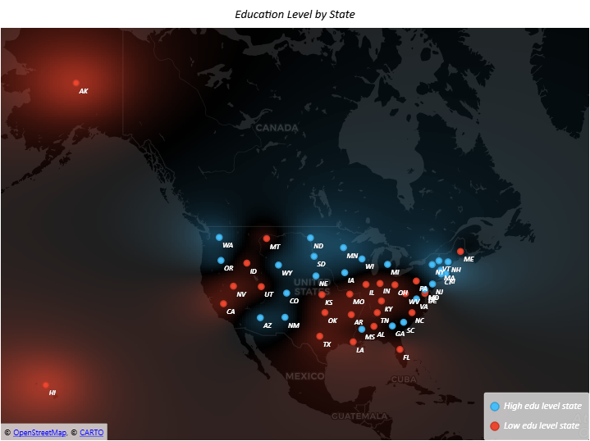

**Figure 39. Biden Won in High-education Level States**

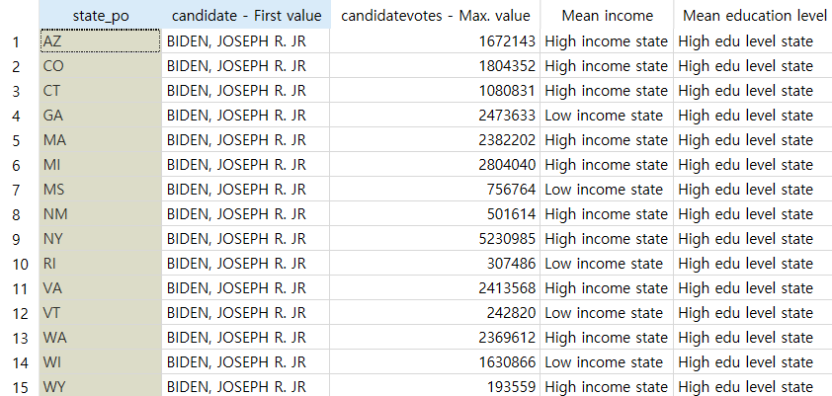

**Part 5.**

This part of the report examines the hypothesis that “higher education levels lead to higher income per hour worked.” Through the examination process, there will be a review of the correlation between education level and income per working hour.

First, the derived variable “Income_per_hour” was added using the formula income/hours. Then, we applied a log transformation to visualise the linear relation better.

**Figure 40.**

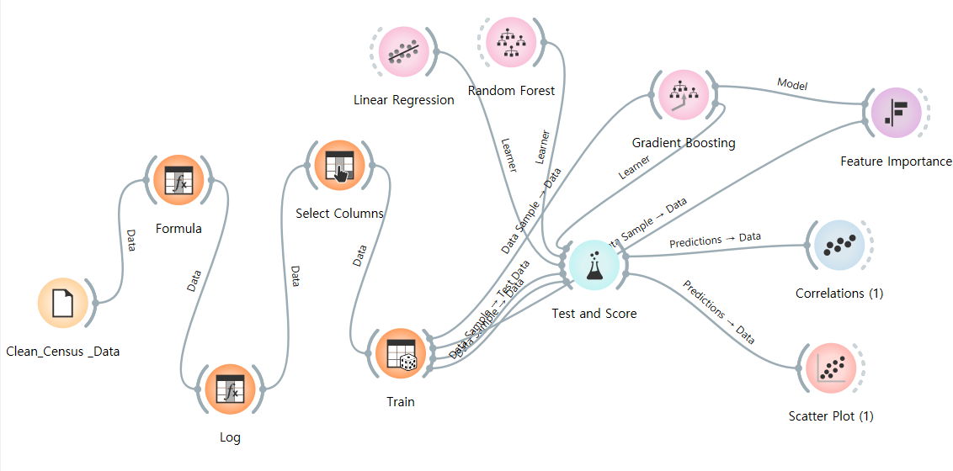

The scatter plot and Pearson correlation showed a positive correlation between Log_income_per_hour and num_edu, scoring 0.32 (Figures 40 and 41).

Furthermore, according to the Gradient Boosting model’s feature importance, the num_edu was the second important variable that would decrease the model performance (Figure 42).

However, according to the test and score in Figure 43, the model performs poorly. This means that it is hard to predict income per hour only using education level.

In conclusion, a positive correlation was spotted; however, it is a weak correlation, and it is expected that other attributes will have a better influence on the income per hour.

**Figure 40.**

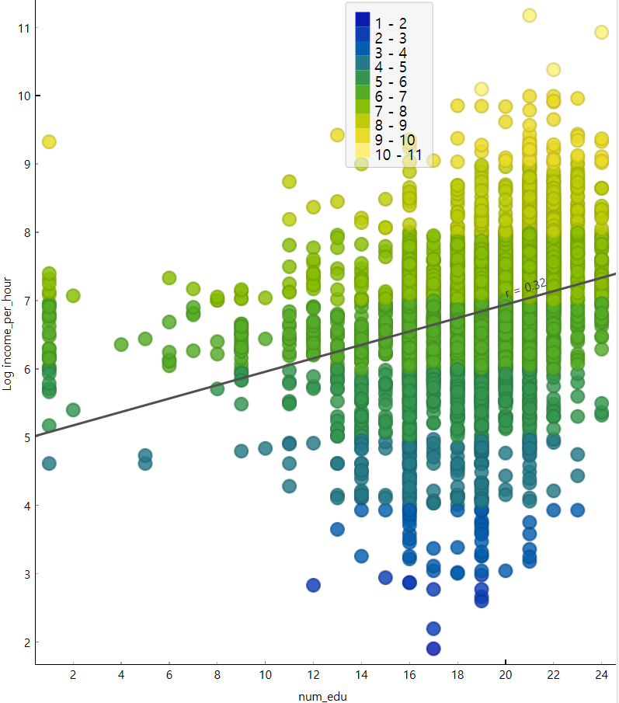

**Figure 41.**

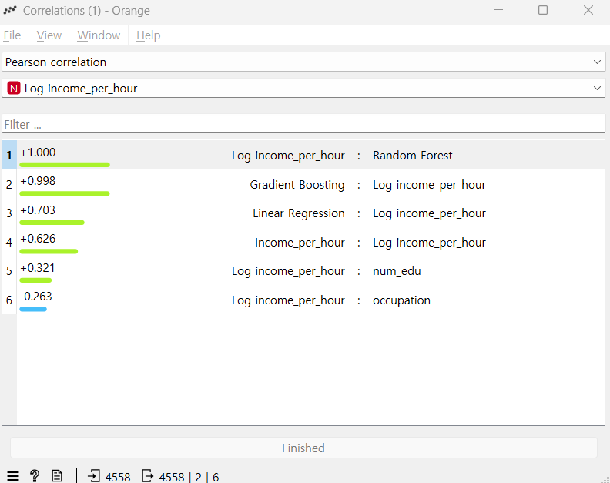

**Figure 42.**

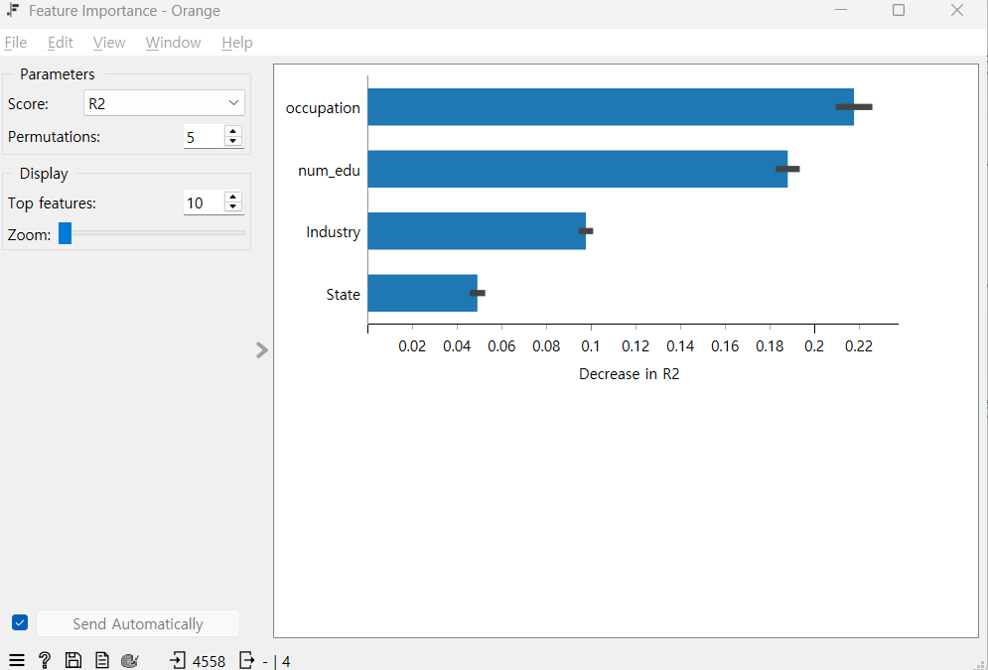

**Figure 43.**

